**LAB 3:**

**Exercise:**

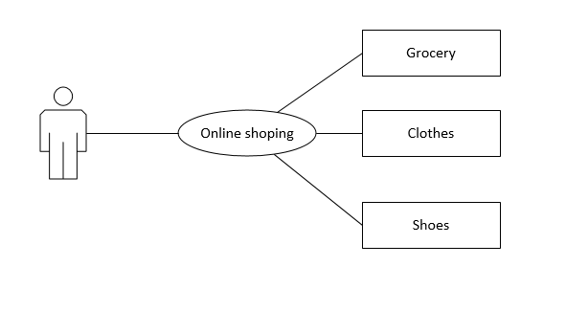Draw a class diagram and sequence diagram for a computer tool that need to extract information from the two different versions of the CAD/CAM system. Both versions are not compatible with each other. This information extraction is required so that an expert system could use it in a particular way. The expert system needed this information to control the manufacturing of the part. Because the expert system was difficult to modify and would have a longer lifespan than the current version of the CAD/CAM system, this information extracting tool should be written in a way that it could easily be adapted to new revisions of the CAD/CAM system. The vocabulary of this system is described in Table 1 and Table 2.

